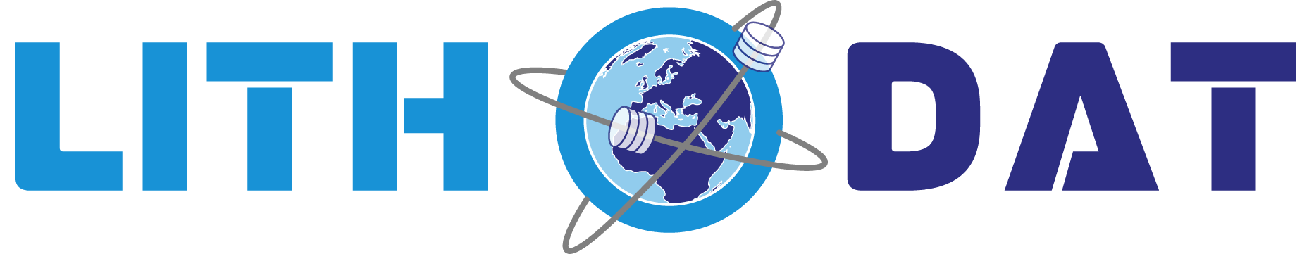

NRCan CATCH Database
Canadian Thermochronology National Data Platform



GDAC-SA Advanced Analytics Platform RFQ
Lithodat Pty Ltd
ABN: 63 627 008 904

Project Overview: The Canadian ThermoCHronology (CATCH) database is a $400,000 CAD national platform integrating 51 years of thermochronology data. Developed by Lithodat for Natural Resources Canada's Geological Survey, CATCH demonstrates direct alignment with GDAC-SA requirements through proven capability in multi-decade data integration, legacy data digitization, and FAIR-compliant national database architecture delivered on-time and on-budget.

1. Overview
The CATCH database is Canada's first unified national repository for low-temperature thermochronology data, integrating 1,427 samples from 91 publications spanning 1970-2021. Developed by Lithodat Pty Ltd (Fabian Kohlmann, Malcolm McMillan) with the Geological Survey of Canada (Dr. Jeremy Powell, Dr. Dawn Kellett), CATCH demonstrates national-scale data standardization directly applicable to GDAC-SA's multi-agency integration requirements.
Performance: $400,000 CAD, 18 months (October 2021 - March 2023), delivered on-time and on-budget. Platform scale: 996 fission-track datapoints, 762 (U-Th)/He datapoints, 16,277 single grain measurements, published via DOI 10.4095/pdreqf905k and accessible through AusGeochem.

2. History & Funding
Natural Resources Canada's Geological Survey (GSC) is Canada's national geoscience organization. Prior to CATCH, Canada had no central thermochronology database despite decades of published research—analogous to GDAC-SA's challenge of fragmented geological survey data.
In October 2021, GSC awarded Lithodat a $400,000 CAD contract to design Canada's first national thermochronology data model, harvest all published research (1970-2021), and integrate with AusGeochem's FAIR platform. The project required systematic harmonization of legacy laboratory outputs from multiple provinces, automated QA/QC pipeline development, and extensive legacy data digitization from analogue paper reports and non-vectorized PDFs.
Deliverables included national data schema accommodating four thermochronometer types (apatite/zircon fission-track, apatite/zircon (U-Th)/He), standardization of 51 years of provincial data, complete harvesting from 91 publications, and integration with international reporting standards.

3. Key Collaborators
Client: Natural Resources Canada - Geological Survey of Canada (equivalent to Saudi Geological Survey).
Project Leadership: Dr. Jeremy Powell (GSC project lead, first author), Dr. Dawn Kellett (GSC co-author), demonstrating government partnership excellence.
Provincial Integration: All Canadian provincial geological surveys contributed data requiring standardization across boundaries—demonstrating multi-agency harmonization applicable to GDAC-SA.
Platform: AusGeochem provides FAIR data access, enabling international research community access through open-source platform.

4. Platform Capabilities
CATCH employs purpose-built data structure accommodating four thermochronometer types (Apatite/Zircon Fission Track, Apatite/Zircon (U-Th)/He) plus thermal history modeling. Canada's first unified national thermochronology schema handles complex kinetic parameters, accommodates legacy laboratory outputs, and provides ML-compatible, cloud-ready structure.
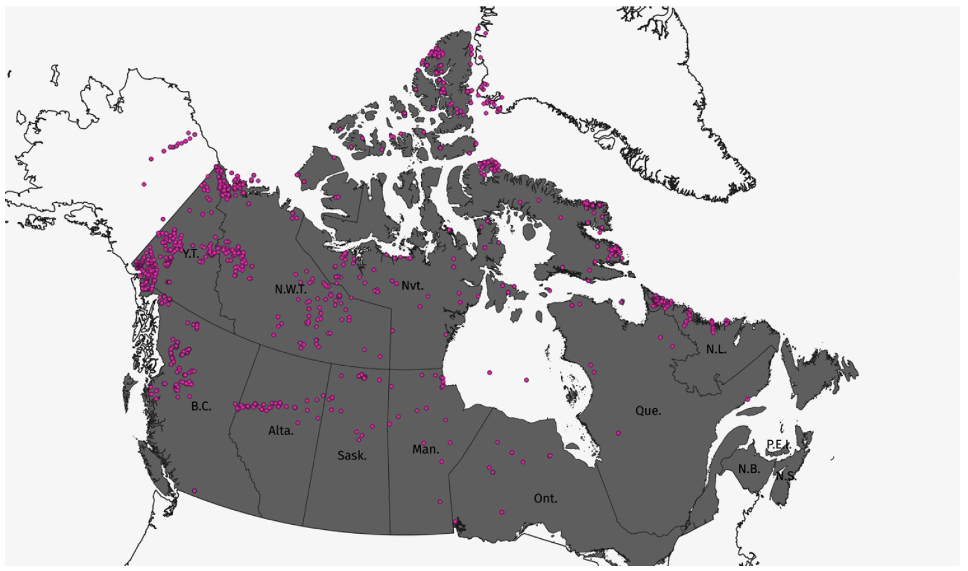
Figure 1: CATCH database northern Canada compilation showing 1,427 sample locations with low-temperature thermochronology data (colored by geologic age: red = Precambrian, green = Paleozoic, blue = Mesozoic, yellow = Cenozoic). Demonstrates national-scale geospatial data integration with complete metadata capture for 51 years of published research. Data accessible via AusGeochem platform.
Advanced Features: Single grain data preservation (16,277 measurements), fission-track length capture (27,848 measurements) from digitized histograms, automated QA/QC pipelines validated by GSC scientists, comprehensive provenance tracking, georeferencing workflow, and thermal history modeling integration.

5. FAIR Data & Project Performance
FAIR Principles: Findable via DOI (10.4095/pdreqf905k) in GSC Open File series; Accessible through AusGeochem platform with no authentication barriers; Interoperable using community-agreed schemas; Reusable with complete metadata and ML-compatible structure.
On-Time, On-Budget: 18-month timeline met (October 2021 - March 2023), $400,000 CAD managed with complete accountability, demonstrating reliable government partnership.
National-Scale Achievement: Standardized data across entire Canadian territory, harmonized provincial inconsistencies, integrated 51 years of data (1970-2021), harvested all published research from 91 sources—demonstrating systematic multi-decade integration applicable to GDAC-SA.
Technical Excellence: Automated data ingestion for multiple formats (digital, analogue paper, non-vectorized PDFs), QA/QC validation by GSC staff, and cloud-ready infrastructure supporting advanced analytics.

6. Publications & Recognition
Powell, J.W., Kellett, D.A., Kohlmann, F., and McMillan, M. (2025). Canadian ThermoCHronology (CATCH) database: northern Canada compilation. Geological Survey of Canada, Open File 9225, 1 .zip file. DOI: 10.4095/pdreqf905k
Official government publication documenting Lithodat's design of Canada's first unified thermochronology data model and curation of 51 years of legacy data. Demonstrates multi-format extraction pipelines, automated QA/QC frameworks, and FAIR data implementation at national scale. The project's scope and methodologies are directly transferable to GDAC-SA's requirements for integrating historical geological survey data with modern analytics infrastructure.
For verification of project performance and technical details, contact:
Dr. Jeremy Powell
Geological Survey of Canada (Natural Resources Canada)
Email: jeremy.powell@nrcan-rncan.gc.ca

Lithodat Pty Ltd | ABN: 48 647 191 452
Platform: https://ausgeochem.auscope.org.au/
Support: support@lithodat.com

